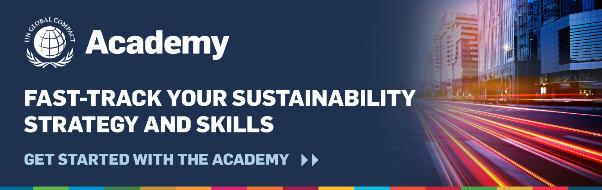

Dear Colleagues,
Did you know that as an employee of [insert company name], you have unlimited access to the Academy, the UN Global Compact’s online learning platform?
Because [insert company name] is a participating company of the UN Global Compact, you can use the Academy, to enhance your sustainability knowledge — regardless of your corporate function or where you are on your sustainability journey. In the Academy sessions, you will learn from industry experts and corporate leaders on key sustainability topics and gain actionable skills that help you and your company move further, faster in achieving sustainability goals. All employees have access to:

- Foundations: Provide a foundational introduction to a topic, and step-by-step models for corporate action. All you need to get started
- Deep dives: Narrow in on a specific topic, industry, function or geography with opportunities to start applying learning within your company
- In-practice exchange: Explore leading practices from companies in your region
- Micro-learnings: Designed to provide bite-sized learnings with a quick overview of key sustainability topics, tools and resources that participants can take to apply learnings within their business practices
- Changemaker Series: Learn from one-on-one discussions with some of the most innovative and influential people working in or with businesses about their insights, experiences and personal take on advancing the Sustainable Development Goals
[Please feel free to forward this e-mail and the flyer from the UN Global Compact Academy to your team and colleagues to help them get started with sustainability.]
You can gain access to the UN Global Compact Academy by requesting access to the Academy today.
For more support on how to use or access the UN Global Compact Academy, please contact academy@unglobalcompact.org.
Sincerely,
[Name]

